Q1.Create and compress the file with bzip2.

Ans. To create a file:

Touch filename.txt

We can compress a file as below, where the flag -z enables file compression:

bzip2 filename

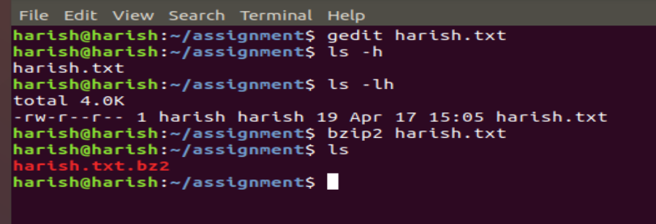

Q2.What would be the argument to be given to unzip that file?

Ans. If the extension of the file is bz2 then it can be unzipped by

bunzip2 filename

otherwise, we can use the following method

sudo apt install unzip

Unzip filename

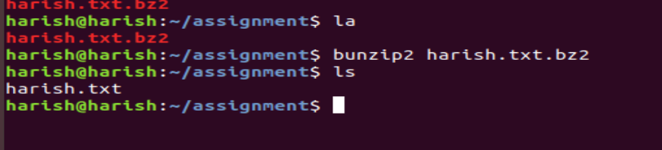

Q3.Read a file and show the data on a terminal using file input and output redirection.

Ans. Cat < filename

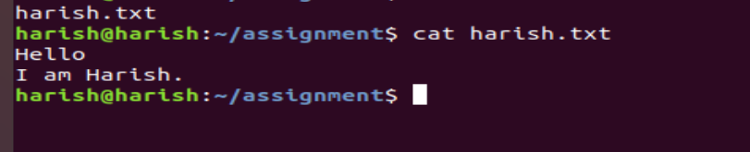

Q4. How to change the shell of the user to “/bin/sh” at the time of adding the user?

Ans.

Syntax:

useradd -s [shell] [username]

For example:

To set the shell of user testuser to /bin/sh:-

useradd -s /bin/sh ashima

submitted by

Harish Kumar Jangir